5 Simple Reasons Your Son Should Do Gymnastics
(Even if He Doesn’t Want to Be a Gymnast)
Gymnastics is not just for girls... Not even close…
Yes, the sport is considerably more popular among girls. But did you know that many regard male gymnasts as the strongest of all athletes?
In Men’s Health’s list of the 50 fittest athletes, it is a gymnast who is ranked third, ahead of sports stars like Michael Phelps, LeBron James and Usain Bolt. And, the magazine admits that the gymnast, Kohei Uchimora, “might be pound-for-pound the fittest guy on the planet.”
.
So that sounds like he should be ranked first to me…
.
Even if your son has no desire to pursue gymnastics as a sport, there are still many benefits for boys to participate in gymnastics. I know that might sound confusing: why would you have your child enroll in gymnastics if he had no interest in being a gymnast?
For these 5 simple reasons…
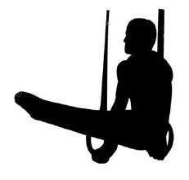
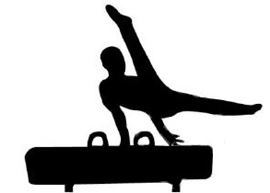
Gymnastics is the perfect foundational sport
There is no sport that teaches basic fundamental athletic skills better than gymnastics, especially for young kids who lack the motor and cognitive skills for team ball sports. In gymnastics class, your son will learn to run, jump, and balance, to develop his coordination and body awareness and to become stronger and more flexible. These basic athletics skills are then transferable to any sport he chooses to play when he gets older. Or, if he opts out of sports all together, he will have a foundation for fitness.
.
Gymnastics is the perfect cross training sport
If your son is already involved in another sports program, gymnastics is a perfect way to enhance his conditioning by building up his athleticism. By participating in gymnastics your son will become stronger, more flexible, more agile and have a better sense of where his body is in the air, all resulting in and overall improvement in his fitness and athleticism.
Gymnastics is the perfect injury prevention program
Two of the most common ways kids get injured in sports are from sprains or strained muscles and from falling. Gymnastics is useful in helping kids avoid sprains and strains because it teaches kids to warm up properly and it helps them increase their flexibility (two of the main reasons sprains and strains occur). Additionally, there is no better place to learn to fall than gymnastics! Part of any core curriculum in gymnastics is learning how to fall safely.
Gymnastics is the perfect character building sport
Coaches want athletes with a strong work ethic and who are resilient. Gymnastics is not an easy sport. It teaches kids that hard work is necessary for results and that trying over and over again is just part of the process. Discipline is a natural byproduct of doing gymnastics.
Gymnastics is the perfect sport to learn to be coachable Gymnastics teaches kids to listen. Gymnasts receive corrections after each and every turn. So a gymnast might receive literally hundreds of pieces of feedback in one practice! Gymnasts learn to not take this feedback as criticism but rather as helpful information designed to improve their performance.
Gymnastics is NOT just for girls. Gymnastics is the foundation of ALL sports. Who knows? Maybe your son will “flip” for the sport and become a gymnast or maybe he will just get some solid building blocks to use in his future athletic endeavors. Either way, it is time well spent getting the recommended 60 minutes (or more) of physical activity per day they need, and they are not in front of a screen!

