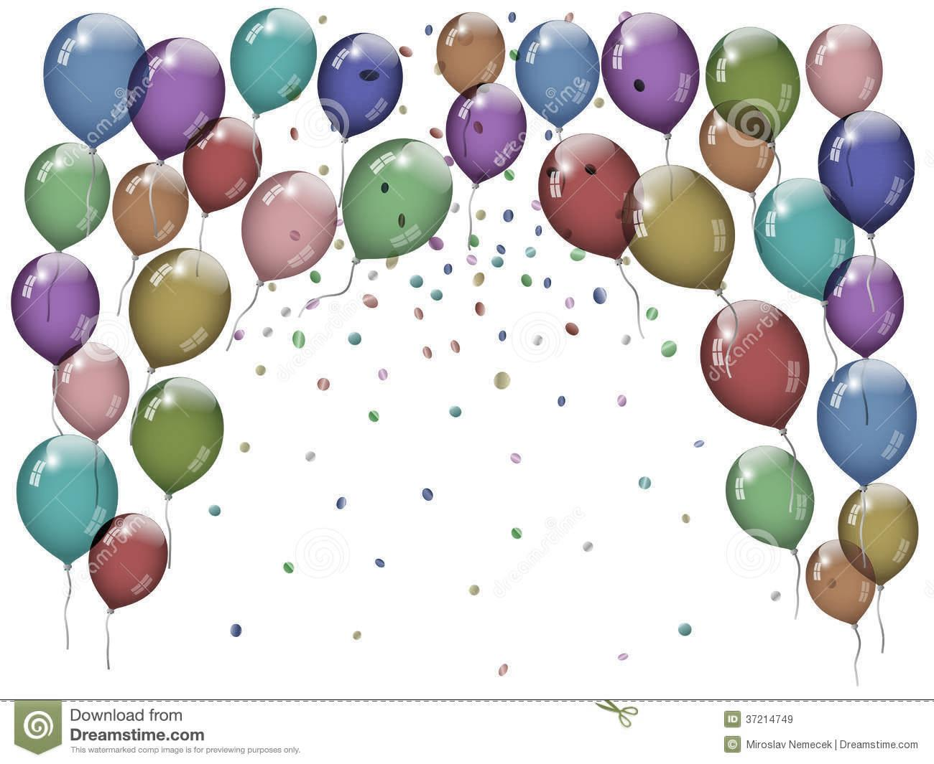  Classic Party  $200.00 | Party Plus  $250.00 | Deluxe Party  $300.00
20  Party Guests  Climate Controlled Play Area  Certified Gymnastics  Coach  2 hour Party:  1 hour 15 min  In play area  45 min for Personal time (I.E. Gifts, Cake, Food) | Includes: Classic Party Package and the following:  Party Hostess  Invitations  Paper Products & Decorations  Keepsake 5x7 Party Picture | Includes: Classic Package, Party Plus Package, and the following:  Pizza for Guests  Birthday Cake  Juice
Party Spectacular
$450.00
Includes:
Classic, Party Plus, Deluxe Package, and the following:

3 Hour Party:
2 Hour 15 min in play area & 45 min for Personal time

Thank You Cards

Goodie Bags
20 Guests Per Party, - Additional Guests are $10.00 Each
* If you wish to add time to your party, it is $50 per half hour
(this must be set up ahead of time)

At AcroBrats Gymnastics
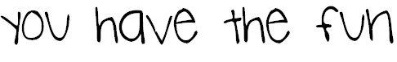

1 - 42 x 44 ft.-competition spring floor  1 - regulation - M/F single bar trainer  1 - Male competition parallel bar set  1 – Male competition high bar  1 - Competition pommel horse  1 - Regulation competition swivel ring set  2 - Male training mushroom | 2 - 30ft Tumble Track training strips  1 - regulation competition table vault  2 - female regulation practice beams  3 - female regulation competition beams  2 - female regulation competition bars  1 - regulation competition specialty bars
Misc. pre-school equipment
Misc. matting and training equipment
(too numerous to list…)

